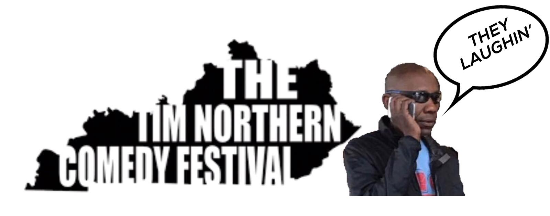
TIM NORTHERN COMEDY FESTIVAL SCHEDULE
Thursday, Sept. 19
Four Pegs Beer Lounge Early Showcase, 7 p.m.
The Caravan Showcase, 7:30 p.m.
The Bard’s Town Showcase, 7:30 p.m.
Four Pegs Beer Lounge Early Showcase, 9 p.m.

Friday, Sept. 20
The Bard’s Town Showcase, 7 p.m.
Four Pegs Beer Lounge Early Showcase, 7 p.m.
Caravan Comedy Competition semifinal 1, 7:30 p.m.
The Bard’s Town Grab Bag Show, 9 p.m.
Four Pegs Beer Lounge Late Showcase, 9 p.m.
Caravan Comedy Competition semifinal 2, 9:30 p.m.

Saturday, Sept. 21
Four Pegs Beer Lounge Showcase, 7 p.m.
Goodwood Brewing Early Showcase, 7 p.m.
Caravan Comedy Competition final, 7:30 p.m.
Goodwood Brewing Late Showcase, 9 p.m.
Caravan All-Star Showcase, 9:30 p.m.
The Bard’s Town Showcase, 10 p.m.

Sunday, Sept. 21
Festival Open Mic at Aloft Louisville Downtown, 8 p.m.

